Autonomous Garbage Collector Rover Using Image Processing

Automatically and Manually Controlled Garbage Collector Rover with Customized Robot Arm

ABSTRACT

We are presenting a smart robot that could present a viable solution towards efficient waste management which is based on embedded, digital image processing. The system is designed such that it can manually as well as automatically detect and collect the garbage. The detection is done by using the image processing algorithm SSD Mobilenet v2, which has been modified by adding our customized layer to the VGG-16 architecture for better detection. The real time video taken by the USB camera will be processed by the Raspberry Pi. For each frame taken it will detect any garbage present in the frame and categorize the detected garbage as Paper, Plastic, Metal or Glass. Once the sorting and categorization is complete the Raspberry Pi will send signals to the robot. Our robot will calculate its position, calibrate the motors according to the position of the garbage so that it will go to the acquired position and collect the garbage with help of customized robot arm. The pre-categorized collected garbage will be dumped in separate parts of a basket labeled as Paper, Plastic, Metal and Glass.

Method with System Diagram/Design Complexity

Our project is basically the idea of detection, sorting and collection.

For the detection part, the system is trained through a dataset using SINGLE SHOT DETECTION (SSD). We developed our dataset which consists of RGB garbage images for both training and testing images of garbage with JPG format. We used 80 percent of the dataset to train and 20 percent to test. Finally we implemented the developed dataset in a Raspberry Pi which helps our robot to automatically categorizing the garbage detected as Plastic, Paper, Glass and Metal. As the system works independently, there is no need of human mediation to control it.

For the collection part, the robot will at first go in front of the garbage and with the help of sonar sensors will calculate the exact distance between the garbage and the robot. Later it will send the data to the Arduino which will decide if it is possible to collect the garbage or not within that calculated distance. If it is possible, Arduino will send a signal to the robot arm to grab the waste in front of it. Once the garbage is collected, it will drop the garbage in a basket which is divided in four parts (Paper/Plastic/Metal/Glass).

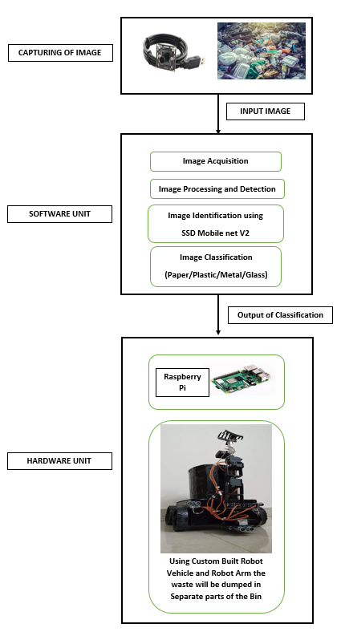

Figure 1: Process of Autonomous Garbage Collection

Novelty of Project and Significance

The proposed system concentrates on identification, classification and segregation of waste. The system isolates waste automatically utilizing sensors, motors and detection software. As the system works independently, there is no need of human mediation to control or to do any assignment. Our robot is different from other garbage collector robots as it can run in any unknown location. We used SSD Mobilenet v2 model for detection of garbage, which is based on VGG16 Convolutional Neural Network architecture. Moreover we improved our detection accuracy by including our customized convolution layers in this model. Sonar sensors allow it to avoid obstacles. SSD Mobile Lite has more accurate detection of garbage which has lower processing power but great detection level. As a result, it will not heat up the processor of Raspberry Pi allowing it to run smoothly. We have also added high power Denso Motors which allow the robot vehicle to easily overcome medium sized rocks. Our robot has a rotating basket divided into four parts (Paper, Plastic, Metal and Glass) attached to a servo. So, if paper is collected the basket will rotate to the side of the paper and the robotic arm will drop the paper in the specific paper part of the basket.

Impact on Society/Environment

Our project helps to collect garbage which can turn unwanted waste into useful substances such as compost and waste energy. The robot can also help to reduce the amount of greenhouse emissions. Further research into incineration and energy recovery can be undertaken. Risk of contamination to ground water systems reduces. . Our project collects plastic from the ground which prevents plastic to get mixed with soil. Dust and litter reduce to surrounding areas. Reduces the demand for landfill sites competes with more sustainable land uses. Research into CO2 and methane emissions associated with landfill and transport is reduced. Minimizes greenhouse gas emissions associated with waste collection, transportation and treatment. Keeps the environment clean and fresh. Saves the Earth and conserves energy. Reduces environmental pollution. Conserves the beauty of nature and landscapes. A spectacular improvement on tourists sites by keeping them clean. Finally, we can help conserve space in landfills and also natural resources such as water, timber and minerals, which would otherwise be used in the manufacturing of new materials. The most important benefit of waste collection with our robot is the protection of nature and health of the entire living population.

Business Model/Financial Scalability Plan

As our project is a waste collecting robot that collects Paper, Plastic, Metal and Glass and keeps them in separate containers, it can play a vital role in the economic sector. It reduces local authority waste management budget due to decreased quantities of waste. Glass, paper, metal and plastic can be recycled which will eventually put less pressure on precious natural resources thus reducing the cost of the production of many products. Collected waste can be recycled and used for other business purposes. Financial benefits to business through reduced expenditure on waste disposal, but also through more intelligent purchasing. Recycling of one glass container saves enough energy to light a 100-watt bulb for 4 hours.

All of the above mentioned economic benefits can lead our robot to a valuable business model. We have planned to sell it to Multinational Companies initially, to collect garbage automatically within their office without any human mediation. Large societies where playgrounds have a lot of garbage is also a prior target to deploy our robot. In playgrounds, we can get a variety paper and plastics which has high recycle value.

Conference Name:ACM Woodstock conference

Conference Short Name:WOODSTOCK’18

Conference Location:El Paso, Texas USA

ISBN:978-1-4503-0000-0/18/06

Year:2018

Date:June

Copyright Year:2018

Copyright Statement:rightsretained

DOI:10.1145/1234567890

RRH: F. Surname et al.

Price:$15.00